**SE&OOAD LAB PROJECT REPORT**

**ON**

**“UML DIAGRAMS ON ONLINE JOB PORTAL”**

**SUBMITTED**

**IN PARTIAL FULFILLMENT OF THE REQUIREMENT FOR THE AWARD OF THE DEGREE OF**

**BACHELOR OF TECHNOLOGY**

IN

**INFORMATION TECHNOLOGY**

BY

**RAHUL TEJA . B** [Reg. No. 18311A12J8]

**UNDER THE SUPERVISION OF**

**Mr. NUTHAN KUMAR G**

**ASSISTANT PROFESSOR, IT DEPARTMENT**



**DEPARTMENT OF INFORMATION TECHNOLOGY**

**SREENIDHI INSTITUTE OF SCIENCE & TECHNOLOGY**

**(AUTONOMOUS)**

**DECLARATION AND ACKNOWLEDGEMENT**

We hereby declare that the work described in the Project report, entitled “**UML DIAGRAMS ON ONLINE JOB PORTAL**” which is being submitted by me in partial fulfillment for the award of **Bachelor of Technology** in the Dept. of **Information Technology, Sreenidhi Institute Of Science & Technology** affiliated to Jawaharlal Nehru Technological University ,Hyderabad, Kukatpally, Hyderabad (Telangana) is the work on my own effort and has not been submitted else where.

I am very thankful to **Mr. Nuthan Kumar G** , IT Dept., Sreenidhi Institute of Science and Technology, Ghatkesar for providing an initiative to this lab project and giving valuable timely suggestions over the work.

I convey my sincere thanks to **Dr.Balaram**, Head of the Department (IT), Sreenidhi Institute of Science and Technology, Ghatkesar, for his kind cooperation in the completion of this work. I even convey my sincere thanks to **Dr. P. Narsimha Reddy** ,Executive Director and **Dr. M.Shiva Reddy**, Principal, Sreenidhi Institute of Science and Technology , Ghatkesar for their kind cooperation in the completion of the lab project.

Finally I extend my sense of gratitude to all my friends, teaching and non-teaching faculty, who directly or indirectly helped me in this endeavor.

Place: **Hyderabad.**

Date: **25-05-2020.** Name of the candidate :

**Rahul Teja B**



**CERTIFICATE**

**Date: 26-05-2020**

This is to certify that the Project report entitled **"UML DIAGRAMS ON ONLINE JOB PORTAL”**being submitted by **Rahul Teja** [Reg. No.18311A12J8] in partial fullfilment for the award of **Bachelor of Technology** degree in **Information Technology** to Sreenidhi Institute of Science and Technology, Yamnampet, Ghatkesar [Telangana], is a report of review work carried out by them during academic year 2019-2020 under our guidance and supervision.

**Mr.Nuthan Kumar G**

Assistant Professor

IT Department

**Dr. BALARAM**

Professor

HOD, IT Department

**Title of the project :**

**“UML DIAGRAMS ON ONLINE JOB PORTAL”**

**Aim of the project:**

Whether entering the job market for the first time or re-entering after a break or switching career, job search is a challenging task. But how about tools/applications, making this tedious process look friendly, systematic and easy to reach out, to employers or candidates. Searching and landing up with a dream job is a tedious process for a job seeker and on the opposite hand, connecting with desirable candidates best fit for a job position is a challenging and important work for the employers. This project is aimed at making such challenges much easier despite the geographic location of either the job seeker or the Company. Although a job search portal doesn’t guarantee a job offer, it is the best place for potential candidates and employers to get connected and know more about each other. “Dreams Job” is an online web application which is a job search portal. It is a simple, efficient, convenient and systematic portal through which job seekers and employers connect with each other. This portal enables candidates looking for jobs to register themselves with the website, look up for different jobs according to their qualifications and apply for those jobs conveniently. Job seekers can also update their details entered during registration as well as their skill sets. On the other hand, employers can register to this portal and publish their jobs which would enable them to find the suitable candidates for their vacant positions.

**Abstract :**

“Dreams Job” is an online Job Search Portal, a web application through which job seekers can register and apply for jobs. Through this portal employers can also post their jobs and review applications. The traditional recruitment systems are time taking and costly. A job seeker must find jobs through advertisements, college fairs, job fairs etc., and the employers must put in much effort to find the right candidate for a vacant position. This application addresses such shortcomings and is a convenient platform for both job seekers to find and apply for jobs and for employers to post jobs and review applications with much ease. Candidates can search for jobs in any field through advanced search capabilities. They can upload their resumes to this application which is stored for future use also. Employers can download these resumes and post/delete job positions. The admin controls this portal and makes the decision about companies and jobs that can access/appear in this portal. Candidates and Employers can use this portal without any geographical barrier, from any part of the world. This application is also developed by using some cutting-edge technologies that are in great demand in the IT industry today. Some of them are NodeJS, AngularJS, Sequelize ORM, etc.

**Software requirements:**

➢ Operating System: Windows 10 ➢ IDE/Text Editor: Sublime Text, Atom, Git Bash CLI ➢ Application Server: Node 3.10.10 ➢ Frameworks/APIs: AngularJS, Sequelize ORM, Swagger, MySQL Workbench ➢ Database: MySQL ➢ Front End: HTML5, CSS3, AngularJS, JavaScript, jQuery ➢ Web Service: RESTful web services ➢ Browser: Preferable Google Chrome or Mozilla Firefox 4.2.2 Hardware Requirements ➢ Processor: Intel core i5 ➢ Processor Speed: 2.50 GHz ➢ RAM: 8 GB

**Introduction Purpose and Scope**

Whether entering the job market for the first time or re-entering after a break or switching career, job search is a challenging task. But how about tools/applications, making this tedious process look friendly, systematic and easy to reach out, to employers or candidates. Searching and landing up with a dream job is a tedious process for a job seeker and on the opposite hand, connecting with desirable candidates best fit for a job position is a challenging and important work for the employers. This project is aimed at making such challenges much easier despite the geographic location of either the job seeker or the Company. Although a job search portal doesn’t guarantee a job offer, it is the best place for potential candidates and employers to get connected and know more about each other. “Dreams Job” is an online web application which is a job search portal. It is a simple, efficient, convenient and systematic portal through which job seekers and employers connect with each other. This portal enables candidates looking for jobs to register themselves with the website, look up for different jobs according to their qualifications and apply for those jobs conveniently. Job seekers can also update their details entered during registration as well as their skill sets. On the other hand, employers can register to this portal and publish their jobs which would enable them to find the suitable candidates for their vacant positions. The Company can view the job applications and take necessary steps. Both companies’ registration and company job posting requires Admin approval to be a part of the job search portal. Some of the existing and old-fashioned methods of 2 recruitment involve advertisements in newspapers, posters, televisions, different job fairs, college career fairs etc. However, such processes are costly and time taking. Handing over paper printed resumes, keeping a track of them, handling and processing them and then getting hold of the desirable candidate to be called for the interview it sounds like a lot of effort and hard work. With the evolution of the world of the Internet and rapid technological advancement, such efforts can be minimized. A job search portal web application comes to rescue at this point where a lot of meaningful time can be saved as well as the cost of advertisements.

**Technology Used and Overall Description:**

This is a Representational State Transfer API following the Model View Controller architecture with NodeJS and its NPM package for the server side, Sequelize, a promise based object relational model, NodeJS web server and AngularJS as the front end with ES6 JavaScript, Html5, CSS3 and jQuery. All validations are done with the AngularJS. I have used MySQL as the database language and MySQL Workbench as the database tool. With an intention to get acquainted with latest cutting-edge technologies this application got that intention reflected in every technical aspect of it. Learning right from asynchronous I/O bound data interaction to dependency Injections in AngularJS this project had been quite a valuable learning process. JavaScript following both Object Oriented paradigm through prototypal inheritance and functional programming paradigm, working with JavaScript frameworks which includes NodeJS and Angular JS this application gave me immense exposure to these technologies.**Video Steganography:** It is a technique to hide any type of files or information into digital video format. Video i.e. the combination of pictures is used as carrier for hidden information. The discrete cosine transform i.e. which is used to hide the information in each of the images in the video, which is not justified by the human eye. It is used such as H.264, Mp4, MPEG, AVI or other video formats .

In traditional web applications, JavaScript is treated as a client-side coding language which enhances and extends the capabilities of client-side coding. However, NodeJS is a programming language that is run on the server side. It is JavaScript itself but enhanced with the capabilities to work as a server-side development language outside the browser. In this project, I have used NodeJS with its famous module Express to achieve server-side functionalities. NodeJS is built on googles V8 engine.

1. **USE-CASE DIAGRAM**
2. **USE-CASE DIAGRAM**

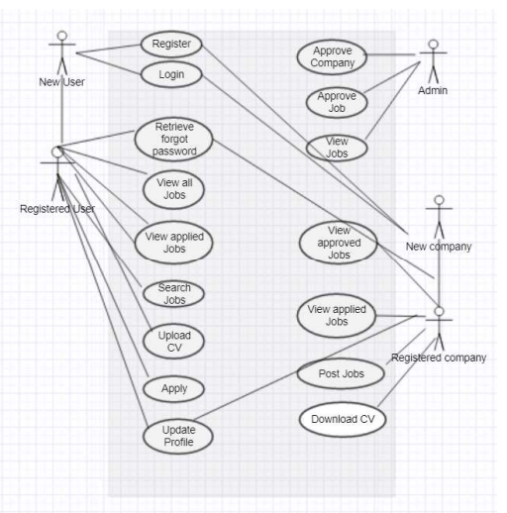

Caption

1. **Sequence Diagram:**

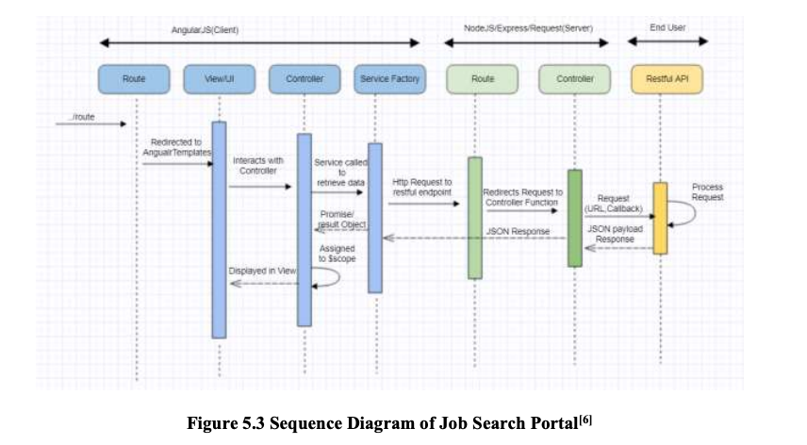

Caption

1. **Activity Diagram**

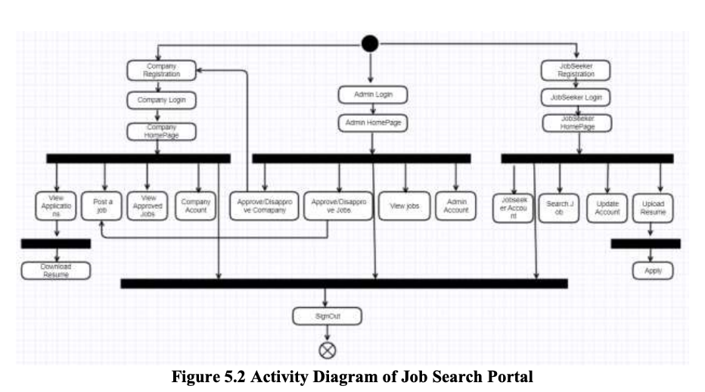

Caption

1. **ER Diagram:**The entity relationship diagram gives a pictorial representation of all the database tables and the relation between the entities. It also shows the cardinality i.e. the many to one or one to one or one to many relationships amongst the tables. This is the first step in designing a database. All the idea of requirements and specification details about the different entities in the database are conceived in the beginning and then transformed into a diagram. This step takes time but once finalized, a good, strong and robust database is a cake walk.

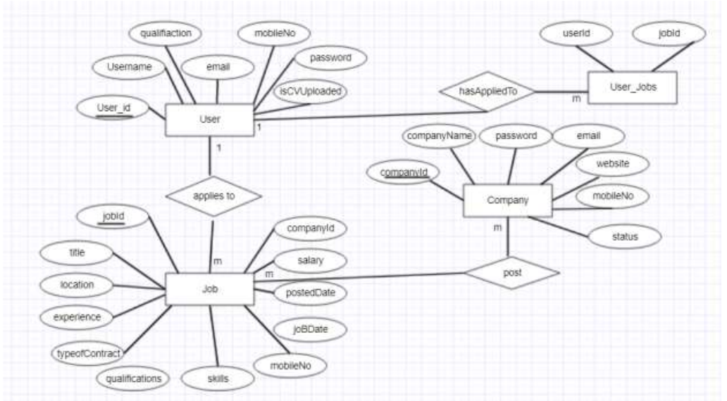

Caption

**Software and Hardware Interface**

**HARDWARE REQUIREMENTS:**

**Hardware :** Pentium IV systems or above

**RAM :** 512MB (minimum)

**Hard Drive space :** 8GB

**SOFTWARE REQUIREMENTS:**

**Operating System :** Windows xp, Windows

**Technology :**  C# .Net

**System Functions**

The proposed system has the following functionalities: ➢ Job Seeker Sign In ➢ Job Seeker Sign Up ➢ Job Seeker can view all available jobs ➢ Job seeker can search based on advanced search ➢ Advanced search can be done on role, salary, technology, etc. ➢ Job seeker can upload resume 21 ➢ Job seeker can apply to more than one jobs. ➢ Job seeker can view all applied jobs. ➢ Job seeker can update their profile information. ➢ Job seeker can retrieve their password if forgot. ➢ Companies can Register to the portal. ➢ Admin approves the company registration, ➢ Companies can post jobs. ➢ Companies can see applications. ➢ Companies can see all approved jobs. ➢ Companies can download resumes uploaded. ➢ Admin can view all jobs. ➢ Admin approves the jobs posted by the company.

Constraints

***Non-Functional Requirements***

The major difference between Functional and Non-functional difference lies in two keywords. “What” and “How”. While what the system does is described by its functional requirements, how the system achieves those quality attributes are discussed by the nonfunctional requirements. The non-functional requirements focus on the scalability of the system, security of the system, reliability and maintenance of the system which are ensured by verifying and validating the system. The proposed system meets the non-functional requirements like security by several form validations and password encryptions, reliability by maintaining integrity with error messages, controlling access of the users. The application is made more scalable with an advanced search feature that filters and delivers 22 requested data from a huge amount of data. Since the application code is modular in nature maintainability and reusability is also ensured.

**Conclusion of the project**

It has been a great pleasure for me to work on this exciting and challenging project. This project proved good for me as it provided practical knowledge of not only programming in ASP.NET and VB.NET web based application and no some extent Windows Application and SQL Server, but also about all handling procedure related with “**UML DIAGRAMS ON ONLINE JOB PORTAL**”. It also provides knowledge about the latest technology used in developing web enabled application and client server technology that will be great demand in future. This will provide better opportunities and guidance in future in developing projects independently.